1. **Steps for attaching and detaching volume,,And check the file exist or not….**
2. **For that we have to create two instances…with different names.**
3. **From that instances select one go to volumes attach to the selected instances..**
4. **While attaching volume check the zone and attach**
5. **Add device name for reference..In that given format**
6. **Finally attach volume to the selected instances…**
7. **Below A. B. C images shown clearly …about attach volumes..**

**Image A**

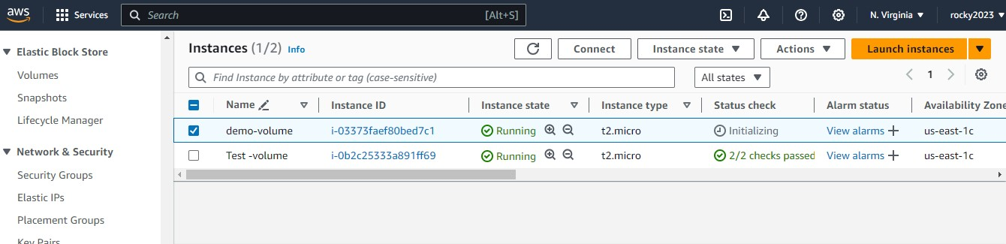

Image B

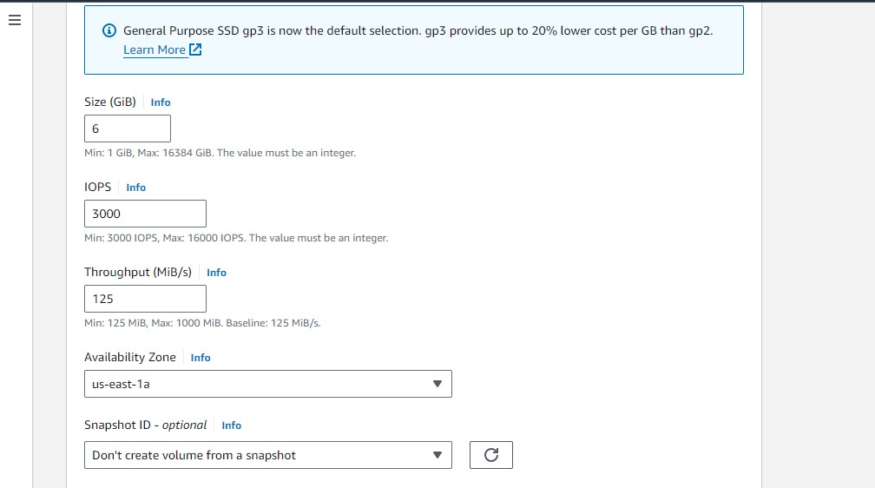

Image C

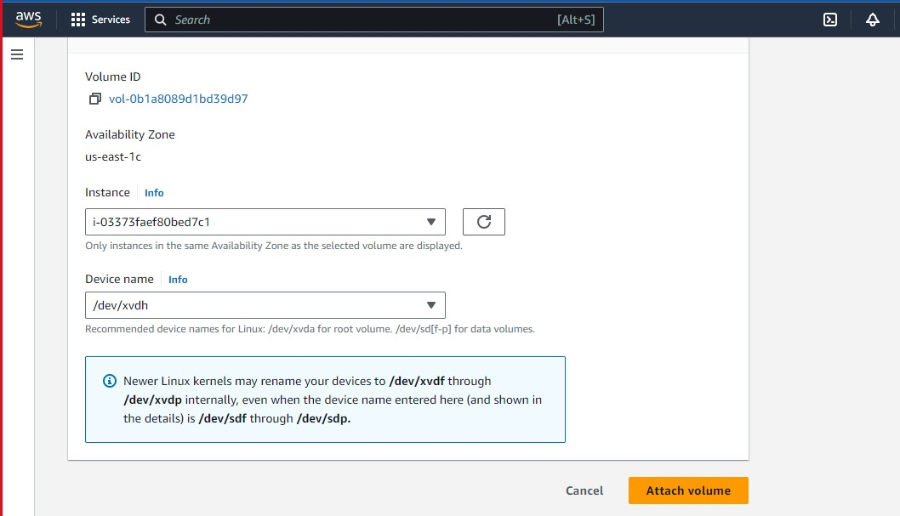

1. **Steps to check the file and mount the volume and Installation of software configuration**

**EX java-basics…**

1. **Below Images A.B.C.**

**Image A:- Steps for Creating Directory after that mounting the volume..**

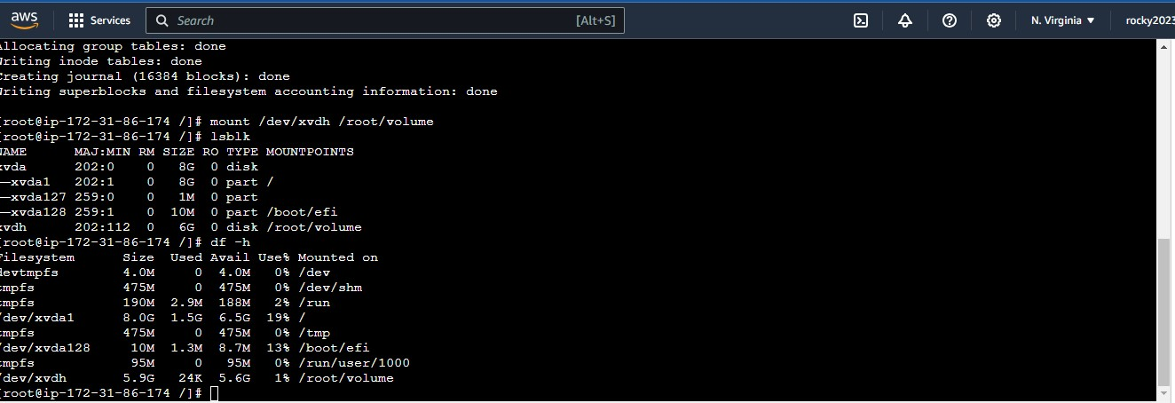

**Image B**

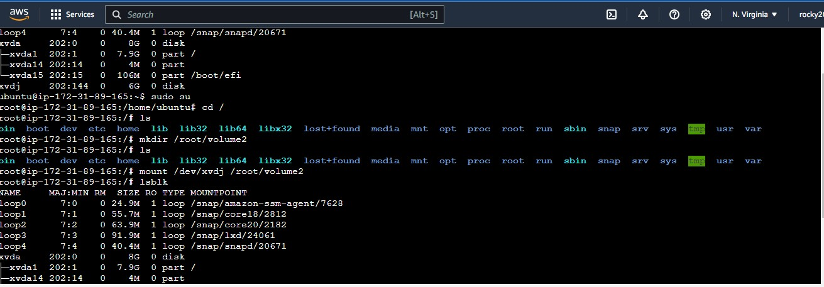

**Image c**

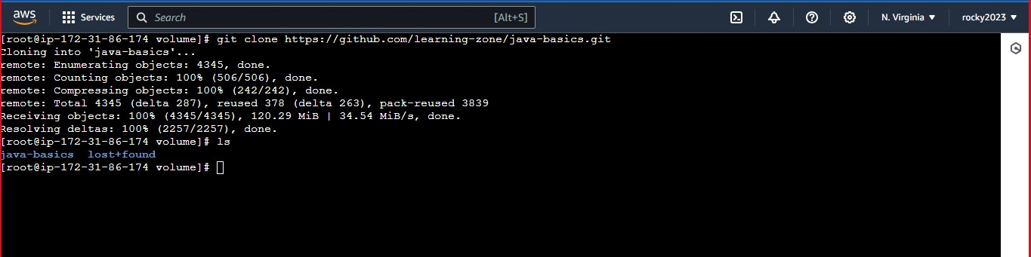

1. **Step for detach volume ..**
2. **Select the instance already attached volume and go to actions their select detach volume..**
3. **Below image shown that detached…**
4. **Again Attach the vaolume for second instance …to check that file what we created …In Image A**
5. **Image B and C shows that already created file ..its available in the second instance..**

**Image A**

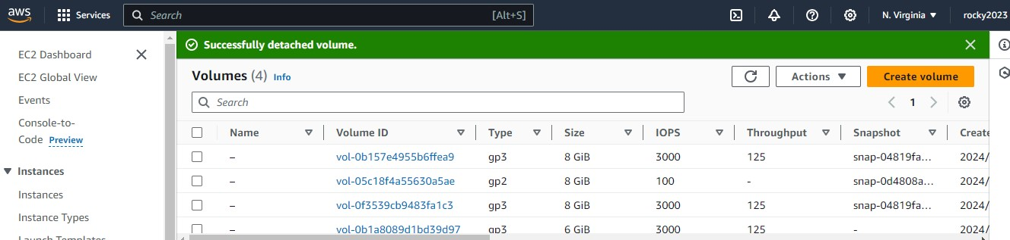

**Image B**

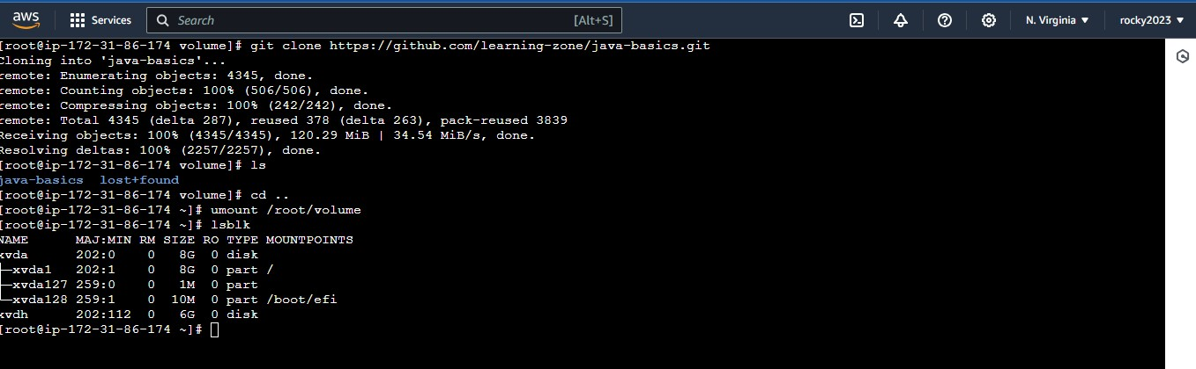

**Image C**



